Adding Linkedin Learning content to QMplus course areas via the LTI (external tool)

- Navigate to the QMplus course area which you wish to add the content and Turn Editing On in the top right corner of the screen

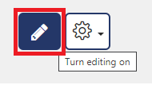

- Select ‘Add and Activity or Resource’ and then choose the ‘external tool’

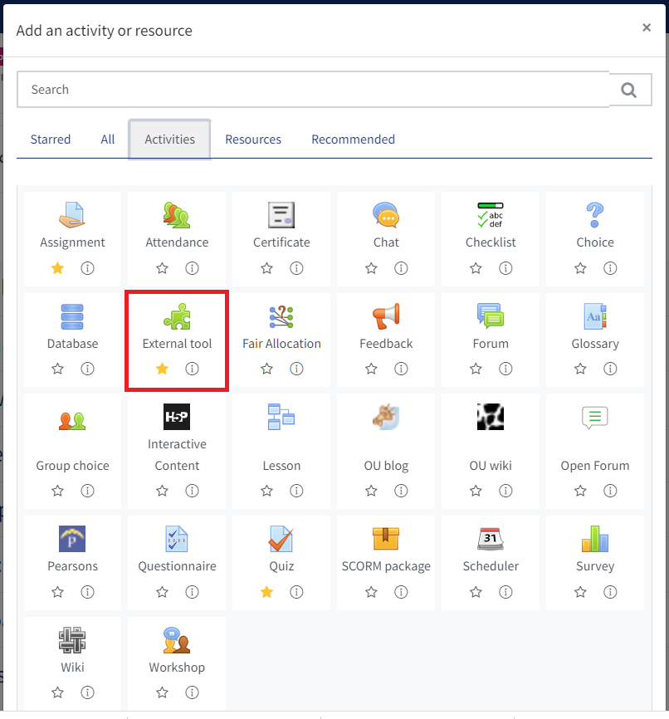

- Give your content a title and select the LinkedIn Learning option from the preconfigured tool dropdown:

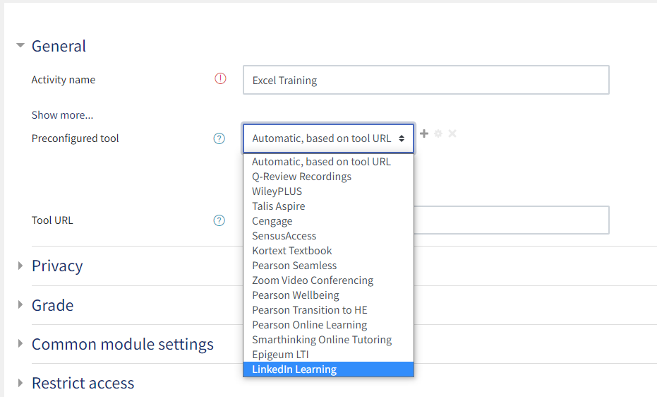

- Click the Select Content button:
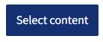

- Search for the content which you wish to add:
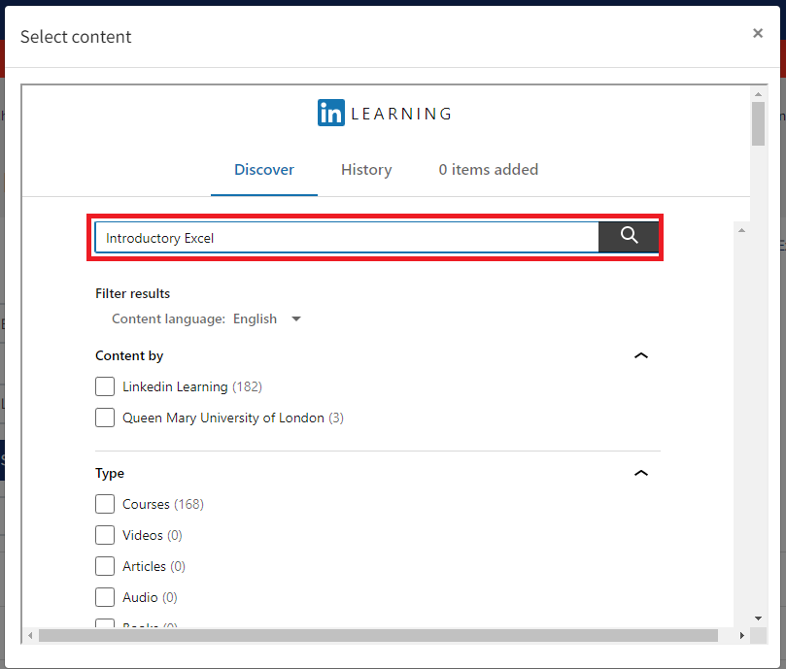

- Scroll down and select the appropriate content via the ‘add’ button:

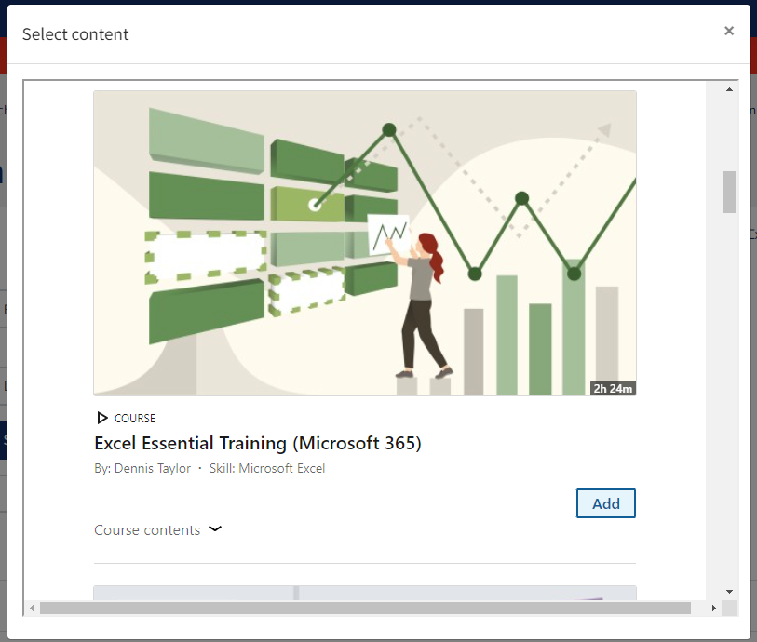

- Scroll to the bottom of the window and select ‘confirm’
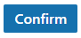

- Save the changes via ‘save and return to course’ or ‘save and display’
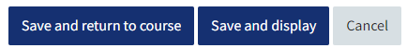
- The content will then display on the module where it was added.

